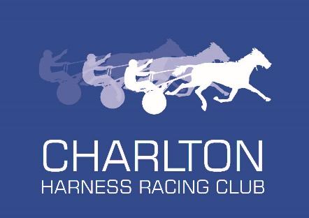

CHARLTON HARNESS RACING CLUB TIPPING COMPETITION
Commencing week beginning 8th June
OBJECTIVES
- To keep members engaged during the period we are not able to race here in Charlton
- Highlight the fun aspect of having a social punt
- Grow membership base through guest participation
- Introduce club profile to a new audience

COMPETITION RULES
- Have fun
- Registration per player - $10 PAYABLE DIRECT INTO CLUB ACCOUNT
BSB 633000 ACC 120810015
- Text name to 0499701322
- Bet to the value of $15 on EACH of the last four races of the meeting eg $10W $5P 0R $15W ETC – THIS IS VIRTUAL MONEY
- WIN AND PLACE BETS ONLY ( to level the playing field for beginners )
- Competition to start week beginning Monday 8th June with a Bendigo meeting – all details will be communicated to participants via text message
- Tipsters to text their selections to 0499701322 by one hour before the first
- Allocated meeting to be advised the week prior
- Leader board updates live on the CHRC Facebook page and will also be texted out to everybody the following day.
- Competition to run for 4 weeks.

PRIZES
- To be announced once registration has closed
- Random betting vouchers to Charlton Cup Day to be drawn throughout the competition

