Contact John Harley  Telephone 0427-701379  Email CharltonPark2020@gmail.com | FOR IMMEDIATE RELEASE  June 3, 2017

$26,500 IN COMMUNITY AND NATIONAL SUPPORT FOR CHARLTON PARK 2020
The Charlton Park 2020 fundraising campaign received a major boost this week with two significant contributions. Firstly the Charlton Urban Fire Brigade made a presentation of $20,000 towards the campaign. In presenting the cheque to 2020 Secretary and fundraising committee member, Kim Thompson, Brigade Captain, Craig Walsh said he was delighted to be able to support the new development at Charlton Park.”It is so important that the community pull together to proved the necessary modern facilities for our town and we are proud to show our support. I urge all community organizations to get behind this wonderful initiative and donate what they can afford to Charlton Park.” Craig indicated that the Charlton Urban Fire Brigade expects to upgrade its own facilities in the near future and “we acknowledge the support we have always had from the Charlton community.”
The fundraising campaign was further boosted by a donation from a national company – the Deutsche Group of $6,500. As part of the campaign, fundraising committee member Kay Cossar has contacted many National companied and she said that she was delighted that their support has started to flow. The Deutsche group has banking interests as well as well known labels such as L’Oreal and Puma.
CHARLTON A&P SOCIETY COMMITS SUPPORT FOR CHARLTON PARK 2020
The President of Charlton Park 2020, Murray McLean has committed the organizations support for the 2020 project. “The 137th Charlton Agricultural and Pastoral Society annual Show will be held on October 21st 2017, at Charlton Park. The Show committee consists of eighteen enthusiastic members, some of whom are new young members.
We see the new upgraded complex providing high standard facilities within the building, and also the elevation ensures a new and exciting dimension for viewing the many events that will take place on the main sporting ground and trotting track.
This committee supports the fundraising campaign for the proposed multi-purpose facility at Charlton Park.”

STRONG SUPPORT FROM CLUBS FOR CHARLTON PARK 2020
Charlton sporting clubs continue to show their support for the new facility at Charlton Park. Charlton Netball Club President, Kim Fitzpatrick said “ it is fantastic that all park users have come together to design a facility that will satisfy the needs of all involved. The current buildings have been in place for a long time and while much care is taken to preserve them as best as possible they are definitely showing their age. The netball club is looking forward to having a new facility with great anticipation. The club is going from strength to strength having the 13 & Under team finish Runners Up and the A Grade winning the Premiership in 2016. Sound numbers see the club field teams in all seven grades, from 13 & Under to seniors. The club also runs a NetSetGo program from April to July each year with healthy numbers. The new facility will be a fantastic space to display club memorabilia and will aid the club encourage new members. It will also be a great venue to utilise when the club hosts North Central Netball Association training sessions and functions. I encourage all netballing families to support the development in any way possible.
In a statement from the Charlton Football Club, President Rod McKee and senior coach Aaron Walklate issued a joint statement. “Having a new state of the art facility at Charlton Park would mean so much to us as a community football club. The facility would enable our players, supporters, volunteers and the community to enjoy the health and social benefits of participating in sport and as part of a club in a comfortable and inviting facility. It gives our members somewhere to hold important family functions as well as giving the club the same opportunity. The facility would give the club the chance to grow and prosper. It gives our current and future generations certainty that Charlton offers a quality sporting experience for them and their Families.”
FUNDRAISING CAMPAIGN CONTINUES
With 3 weeks to go before the end of the financial year, Campaign chairman Peter Whykes urged local Charltonians who have not got around to making a donation yet, to contribute. “ I urge them to make their donation in the next 3 weeks” he said. “The committee is working very hard and in the last 2 weeks has made contact by email or letter with over 600 ex-residents of the town”. Already donations are coming in with $1000 from both John Carmody and Peter Noonan, $200 from Ron Bartlett and $20 from Kathie Secombe and we thank them for their donations.
Donations in the last week include $2000 from Peter and Robyn Soulsby, former residents of Charlton. In making their donation, Robyn wrote, “ Good luck with the fundraising for this wonderful project”.
There was also a$100 donation from former residents Tony and Teresa Lane, all the way from Western Australia as well as a contribution from the Charlton Croquet club and notification of a doubling of the contributions from 2 of the park users, Charlton Hockey Club and the Junior Football Club which is also fantastic news.
Other Recent Donations
Bronze- Leo and Kath Noonan - $1,000
Laurie Harvie - $1,000
Two anonymous donations of $1,000
Supporter- Kevin and Heather Willey - $200
Three anonymous donations of $100

Every dollar will help shape Charlton’s future, so please give as generously as possible.
# # #

If you would like more information about this topic, please contact John Harley at 0427-701379 or email at jharley21@bigpond.com

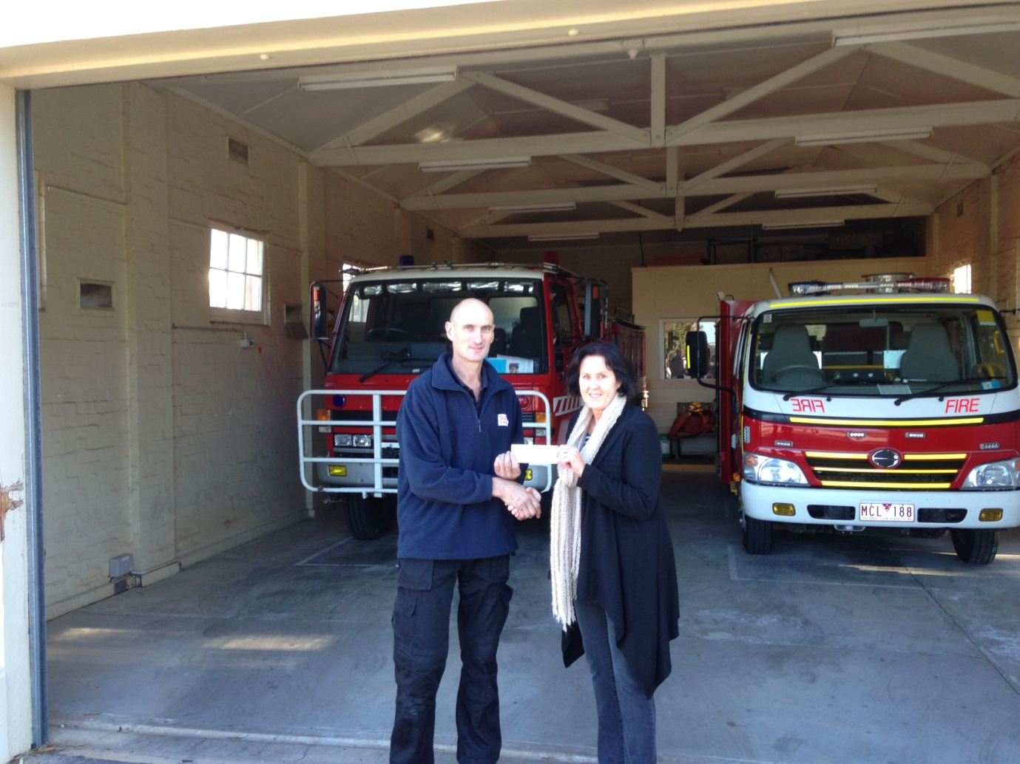
Charlton Urban Fire Brigade Captain, Craig Walsh presents a cheque for $20,000 to Charlton Park 2020 Secretary, Kim Thompson
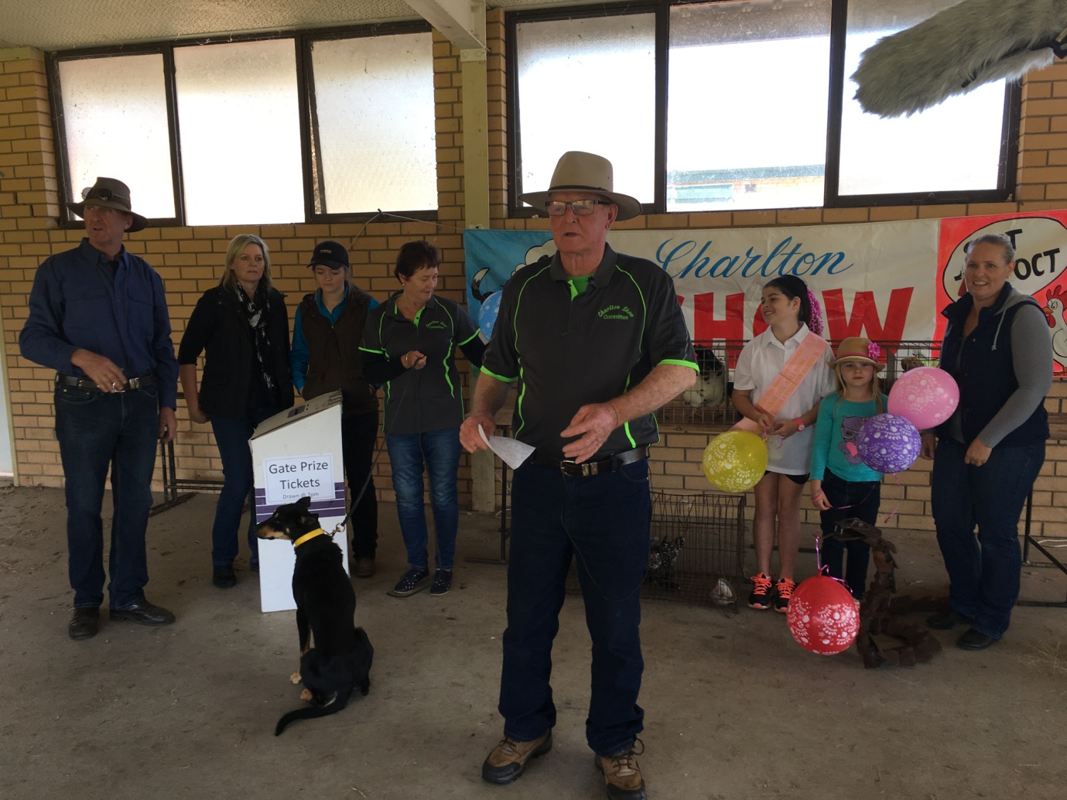

A&P Society President Murray McLean speaking about the support of the Charlton park 2020 development. Listening on are L-R – Joe Thompson, Sophie Lang, Caitlin Lang, Secretary Wendy Laffin, Taylor Boyle, Stella Nicolson and Amy Nicolson
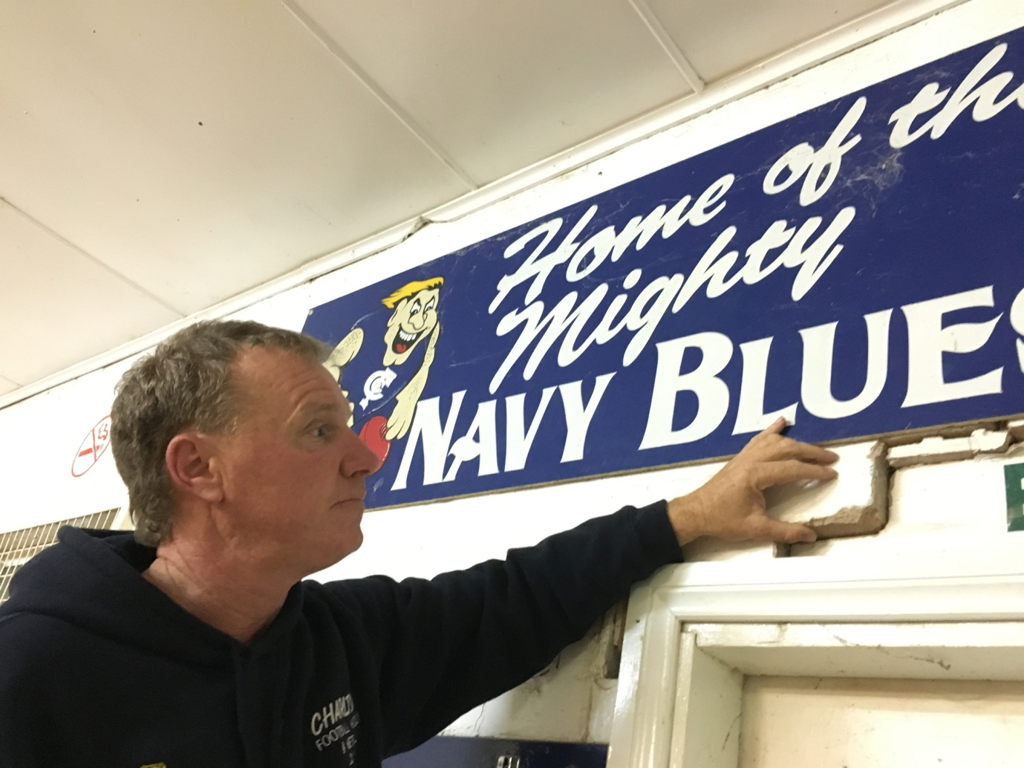
Charlton Football Club president, Rod McKee examining the ageing social club building at Charlton Park

