CHARLTON TROTS MONDAY 10TH APRIL
DJA DJA WURRUNG CUP DAY
The Charlton Harness Racing Club were thrilled to once again host the Dja Dja Wurrung People at the annual Dja Dja Wurrung Cup Day yesterday. As a gesture of thanks for permission granted to build our Training Facility, now a great asset to the club, this day has evolved into one of friendship and mutual respect. With 40 representatives of the Dja Dja Wurrung People on course to participate in the day it was a great testament to the growing relationship between the two groups. In a day of many positives perhaps the most important was the commitment made to work even closer together to develop this day into a showcase of the best that the CHRC and the Dja Dja Wurrung People have to offer. Congratulations to Damien Burns and Village Tango – a Cup presentation that will long be remembered.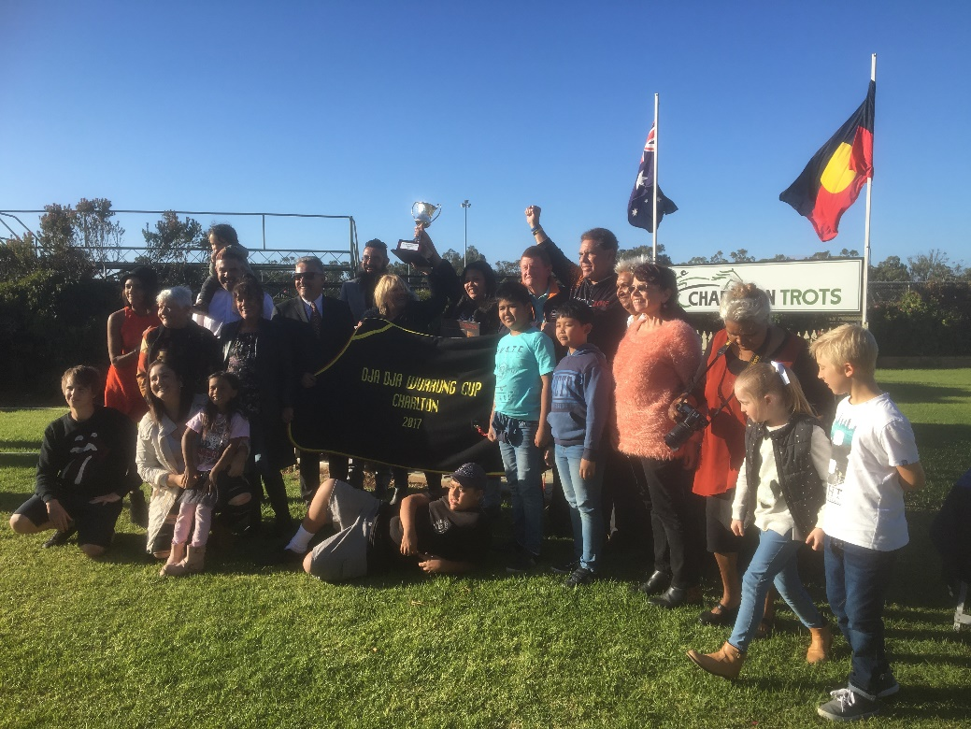
PRESENTATION TO THE WOMEN’S CANCER FOUNDATION
It was with much pleasure that the Charlton Harness Racing Club welcomed Teal Campaign founder Duncan McPherson on course to accept the $2829.00 raised to support Ovarian Cancer research on Charlton Cup Day. In a very successful ladies event ‘Bubbles In The Bush’ proudly sponsored by St. John Of God Bendigo Hospital, 104 ladies dug deep to support this most worthy of causes and helped to bring much needed awareness to issues surrounding this disease. In an unexpected but generous gesture the tone of the day was personified when Rodney Carter representing the Dja Dja Wurrung People stepped forward to announce that they also would like to donate $1000 to the Women’s Cancer Foundation. And so a new relationship was formed.
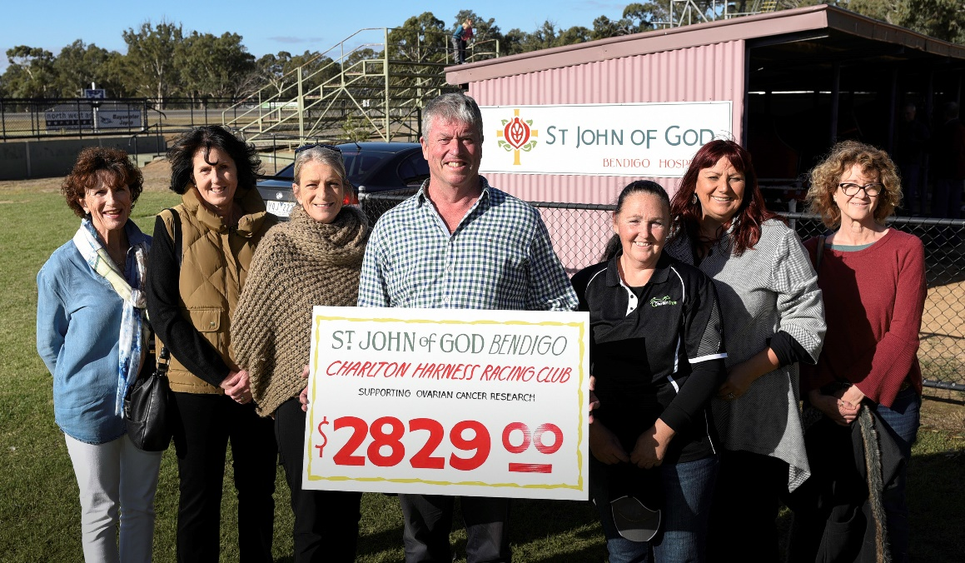
PICTURE COURTESY OF THE BULOKE TIMES
OPENING OF THE MILLY PEREZ BAR
It was with great pride that local and ex President of the Charlton Harness Racing Club Frank McGrath was given the honour of opening the new Milly Perez Bar at the club. As a long time supporter of harness racing and a passionate Charltonian, Frank was humbled to have this recognition given his super mare after her stirring win in the Charlton Cup in February. The club was very keen to acknowledge her feat as it is an important chapter in the rich heritage of racing in Charlton. With both the Charlton Cup and the recently won Mildura Cup on hand we were reminded it is moments like these which bring club members together and help to promote how exciting harness racing can be. Charlton will again be following Milly as she heads to the Ararat Cup.
