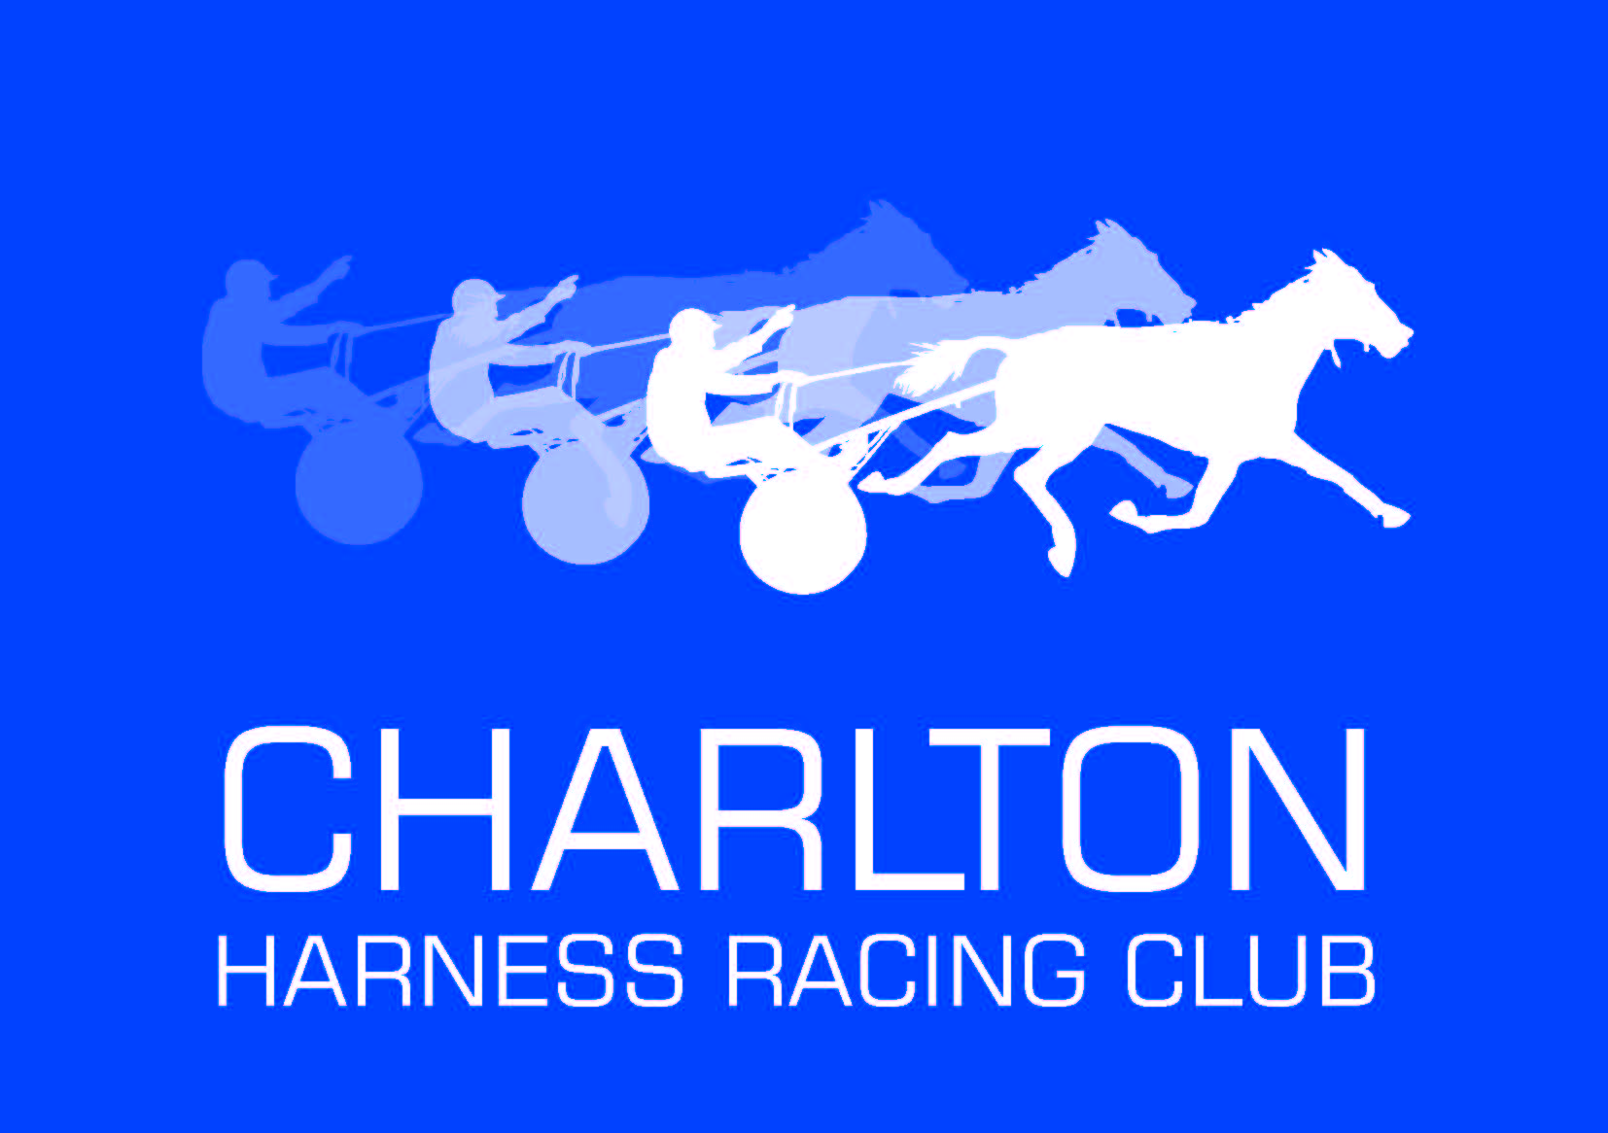

MEMBERS NEWSLETTER
NOVEMBER 2014
*ANNUAL GENERAL MEETING
The Clubs AGM was held on Monday, October 13th.

A copy of President John Tormey’s Presidents Report is attached for your interest.

Following elections, the Club’s Committee for Season 2014-2015 will be : John Tormey (President), Janice Boyle and Jim Harvey (Vice Presidents), Anne Marsh (Treasurer), Greg King, Dianne Harvey, Doug Gretgrix, Joe Thompson, Mark Boyle, Kirk Boyle, Peter Hobbs, Andrea O’Gorman.

Club Membership will remain at just $10 for the 2014-2015 Season.

*NEW CHARLTON HRC WEBSITE
The new Charlton Harness Racing Club Official Website has now gone live!

Found at www.charltonharnessracingclub.com.au , the website provides a huge range of Club and Harness-related information where Members can keep up to date with the Club’s racing and social events, news and contacts.

Key sections include:
- “Latest News”, where Members can read of recent racing results, general interest stories, achievements, upcoming events and other harness racing news.
- Club Contact Details, as well as Track and Committee Information.
- History of the Club and Photo Gallery featuring various aspects and features of the Club.
- Racing Information, including the Charlton Racing Calendar and links to fields, results and Stewards Reports via the Official HRV Website.
- Members Information Section, which includes details on the list of Member Benefits and Newsletters.
- Social Club News.
- Local Trainer Profiles and Sponsor Details.
- Links to other interesting and relevant websites.

Built by local Charlton resident Kelvin Getley and designed by Charlton Committee Member Andrea O’Gorman, the website is simple to navigate and provides the viewer with a huge range of interesting information about the Club and harness racing in general. It will be updated regularly and Members are encouraged to check out this wonderful new resource.

*CHARLTON HRC CHRISTMAS FUNCTION – SUNDAY, NOVEMBER 30th = ALL MEMBERS WELCOME
See the attached Flyer for full details. This features the 2013-2014 Season Members Cash Draws.
Note: Members must be present to receive the full prize value if drawn.

*NEW CENTRAL VICTORIAN CHAMPIONSHIP SPONSOR
In exciting news for the Central Victorian Harness Racing Clubs, the Harness Racing Training Centre Bendigo has been signed as the naming rights sponsor for the “Harness Racing Training Centre Bendigo 2015 Central Victorian Pacing And Trotting Championships”.

The new Sponsorship Agreement will see the Harness Racing Training Centre Bendigo providing cash support for the provision of trophies and other benefits for the winning owners, trainers and drivers of both Finals, whilst John and Kay Campbell of Loddon Valley Stud will be providing Stallion Service Fees to the winners of each respective Final. These benefits will be a huge attraction to owners and trainers, as will the $20,000 prizemoney allocated to each Final.

This year’s Finals Heats and Finals should again attract some classy up-and coming stars, if past winners are any guide, with recent winners of the Pacing Series including horses of the calibre of Sapphire Swayze, Restreppo and Bitobliss, and in the Trotting Series The Boss Man, Tendaho and Living Bonus.

Another key aspect to the Sponsorship will see the Harness Racing Training Centre Bendigo sponsoring the “Harness Racing Training Centre Central Victorian Concession Drivers Championship”. Featuring a Concession Drivers race at each of the Maryborough, Boort, Wedderburn and Charlton Central Vic Meetings, the Championship will also include the provision of trophies to the winning trainers and drivers of each race, as well as a trophy going to the concession driver accumulating the most points over the four race Series.

*NEW PACING CUP SPONSOR FOR 2015 CHARLTON PACING CUP
In further exciting news for the Club, the Charlton And District Community Bank has been secured as the naming rights sponsor for the 2015 Charlton Pacing Cup. To be known as the “Charlton And District Community Bank 2015 Charlton Pacing Cup”, the race will be the feature of the Cup Day Program, to be run this year on Sunday, February 15th.

*UPCOMING RACE DATES
- Monday, November 24th Charlton Meeting
- Monday, December 8th Charlton Meeting = Snowball Series
- Wednesday, December 30th St. Arnaud at Charlton (note change from 07/01/15)
- Wednesday, January 7th Boort at Charlton = Central Vic Heats (note change from
01/01/15)
- Thursday , January 22nd Charlton Meeting = Central Vic Finals
- Thursday, February 5th Charlton Meeting
- Sunday, February 15th Charlton Meeting = Charlton Pacing and Trotters Cups.

*EMAIL ADDRESSES AND MOBILE PHONE NUMBERS
If you currently receive this Newsletter by land mail or are not receiving regular sms messages on your mobile phone then I do not have your email address or mobile number. To assist with effective communication and save the Club costs on land mail, could you please forward these details to me.

Gary Cooper Secretary - Charlton HRC. Ph. 5439 7401 Email garyjcooper@bigpond.com

PRESIDENTS REPORT 2013-2014

I would like to begin by thanking the Committee for all their efforts and work throughout the year. We have enjoyed a very stable, enjoyable and financially successful year, and the injection of a number of new Committee Members has bought a new vitality and energy to the Club.

Thank you also to Gary and Anne for their work as Secretary and Treasurer, to Doug for his efforts in maintaining the Complex so well and for helping to prepare the track, and to Jimmy and Di for their efforts in the Bar and for also helping to present the Facility so well. It was interesting to note that Charlton received a nomination for the “Best Presented Venue” at the recent Rothacker Awards, and whilst we did not win, it was good to see that people were noticing the efforts being made to present our venue so well.

As I said before, the year has been a very successful one. There have been many notable achievements:
- We have paid off the Track Loan.
- All Flood Works have now been completed and signed off.
- We have purchased a new tractor and the purchase of a track vehicle is imminent.
- The Home Turn Upgrade Works are ready to go.
- The new Club Website is nearly ready. Thanks to Andrea for all her work here.
- The Training Centre continues to develop, with a new person hopefully moving in in the next few weeks. The issue of finding suitable rental housing, however, still hampers the development here.
- The Training Track has also been top-dressed.

The Social Committee has been a huge success, which was shown by the running of the Bus Trip to Ballarat recently. Thanks to those involved, and particularly Di, Andrea, Janice and Greg.

Thanks also to Joey for his support throughout the year.

Looking towards the future, the 2020 Project should be our top priority. It will be a great asset for the community as well as the Trotting Club, and it will help to guarantee our future if we can bring it to fruition. Our financial position is quite positive and should remain so if we continue watching it closely. Maybe finances might even permit the purchase of a grader for the track if a supporting grant can be secured.

All in all it has been a successful year, with new Committee Members adding a new lease of life with some new ideas and the regulars all working together to make our Club an enjoyable and productive Club. After 9/10 years as President over two stints I am more than happy to step aside if someone else wants to do it.

John Tormey
President – CHRC
2013-2014

Charlton Harness Racing Club Member’s Xmas Party is on….

Sunday 30th November
4pm start for 6pm BBQ
Fully Catered
RSVP please by Wed 26th
email andrea andreaog@bigpond.com 0413384500
di dianneharvey@southernphone.com.au 54912181
greg greg.d.king@bigpond.com 0432538118

ALL WELCOME – SEE YOU AT THE TRACK

